**Expense Tracker Application - Phase 10: Go-Live, Training, and Project Handoff**

**Objective:** To successfully launch the Expense Tracker application to all end-users, conduct role-specific training, demonstrate the final product's value to stakeholders, and deliver all necessary documentation for long-term maintenance and future development.

**Step 1: Conduct End-User Training and Go-Live**

* **Purpose:** To ensure all stakeholder groups are proficient in using the new application before it becomes the official system of record.
* **Actions:**
  + **Role-Specific Training:**
    - **Employee Session:** Train the "Expense Employee Profile" users on:
      * Accessing the new **'Expense Tracker' Lightning App**.
      * Submitting new expenses using the **"Submit Expense Form" Screen Flow**.
      * Understanding the **Approval Status** picklist (Pending, Approved, Rejected) on their records.
    - **Manager Session:** Train the "Manager" role users on:
      * Monitoring the **'Expense Tracker Dashboard'** , focusing on the 'Pending Approvals' component.
      * Reviewing, approving, and rejecting submissions from the **Approval History** related list or custom LWC buttons.
  + **Go-Live Activation:**
    - Formally activate the **Lightning App** and **Lightning Record Pages** as the default for all target profiles.
    - In Production, schedule and activate the automated Apex jobs: **ScheduleOverdueExpenses** and **DailyExpenseSummary**.
    - Send the official company-wide launch communication.

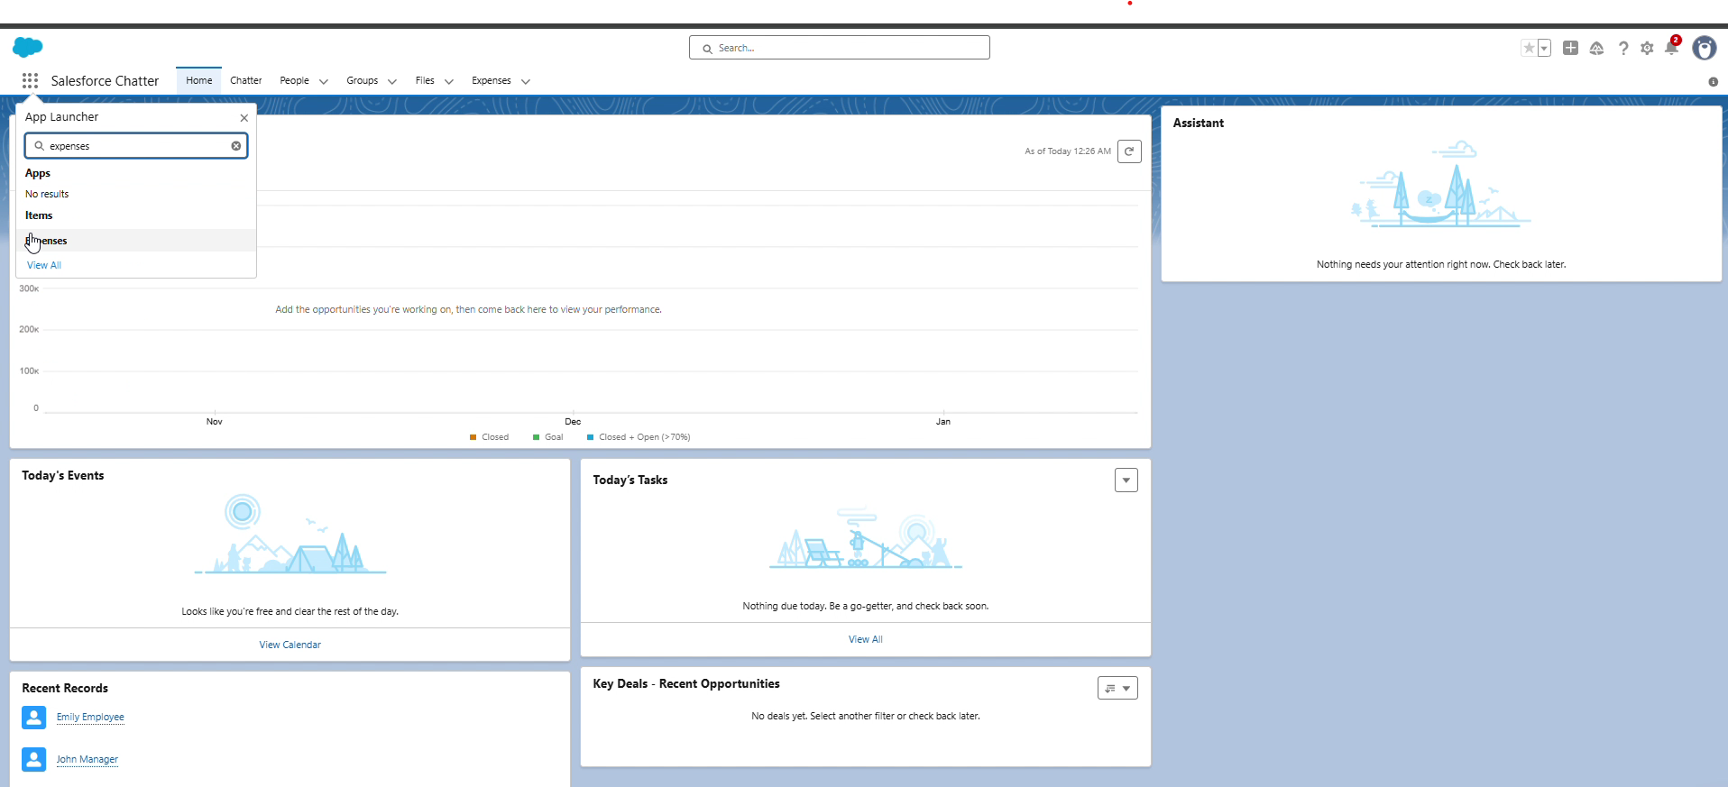

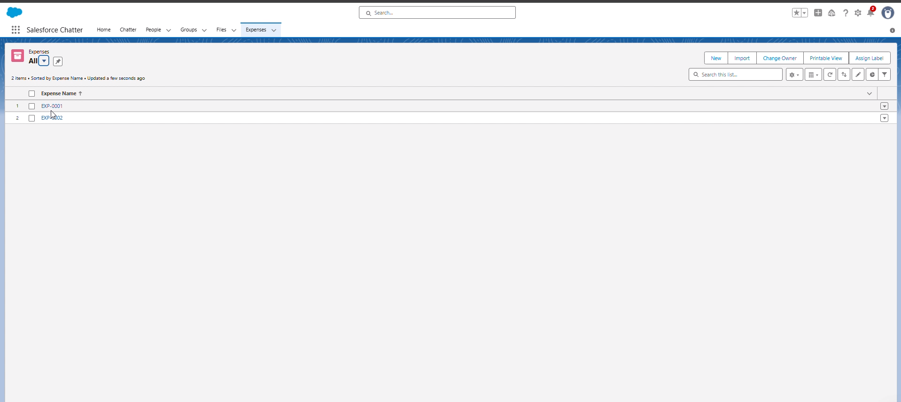

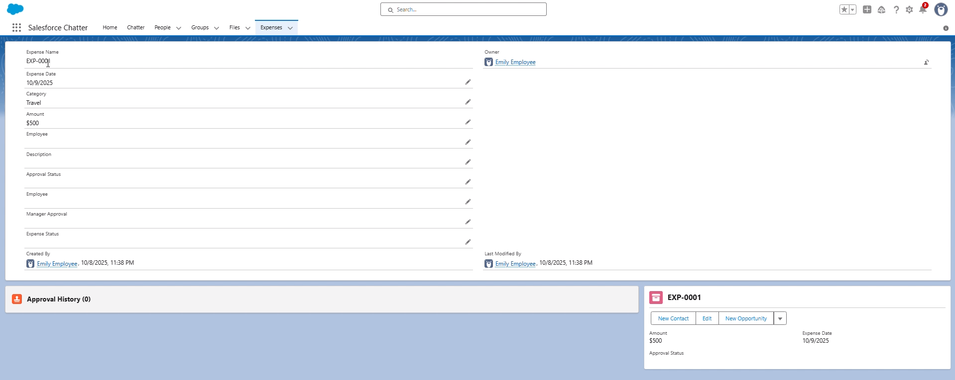

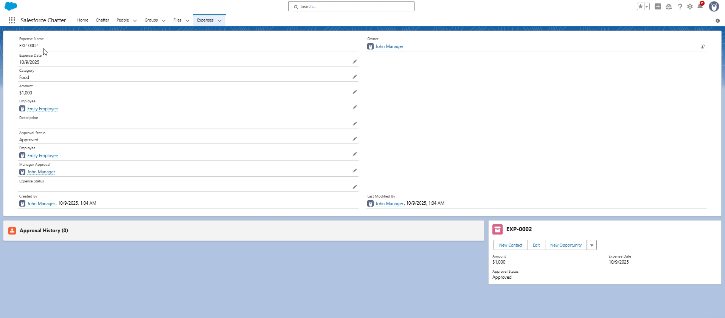

**Step 2: Final Stakeholder Presentation and Demo**

* **Purpose:** To demonstrate the full, end-to-end business process and showcase the value delivered to executive and finance stakeholders.
* **Actions:**
  + **Pitch Presentation:**
    - Begin by restating the core problem from Phase 1: inefficient, manual, and error-prone reporting.
    - Present the solution: a unified, automated, and secure platform.
    - Emphasize key value propositions:
      * **Data Integrity:** Showcase the Validation Rules (Amount_Positive, Date_Not_Future) that enforce policy automatically.
      * **Process Efficiency:** Highlight the automated **Expense Manager Approval** process that routes claims to the correct manager.
      * **Actionable Insights:** Feature the **Expense Tracker Dashboard** as the tool for real-time leadership visibility.
  + **Live Demo Walkthrough:**
    - **Employee Persona:** Log in as the "Employee User". Navigate to the **Expense Tracker** app and submit a new expense using the Screen Flow.
    - **Manager Persona:** Log in as the "Manager User". Show the new expense appearing on their **Home Page** dashboard and/or in their approval queue. Approve the record.
    - **Finance/Admin Persona:** Refresh the **Expense Tracker Dashboard** to show the newly approved data reflected in the 'Expenses by Category' pie chart and other reports.

**Step 3: Collect Feedback and Establish Support**

* **Purpose:** To gather immediate feedback from the live-user experience and establish a "hypercare" period for rapid support.
* **Actions:**
  + **Feedback Mechanism:** Distribute a simple survey or feedback form to all trained users, asking for specific feedback on the submission flow and dashboard usability.
  + **Monitor and Support:**
    - Establish a clear support channel (e.g., a dedicated email or Chatter group) for the first 30 days.
    - Admins actively monitor for any automated error notifications from Flows , Apex , or batch jobs.
    - Review the **Setup Audit Trail** and API limits to ensure system health.

**Step 4: Deliver Final Handoff Documentation**

* **Purpose:** To equip the System Administrator and IT department with all necessary documentation to own, maintain, and enhance the application.
* **Actions:**
  + **Configuration Guide:**
    - Provide a full data dictionary for the **Expense__c** object and all its custom fields.
    - Document all automation logic, including Validation Rules , the Approval Process , and all Record-Triggered Flows.
  + **Technical (Apex/LWC) Guide:**
    - Hand off all Apex classes, clearly explaining the logic in:
      * ExpenseService (Trigger Handler)
      * ExpenseTrigger
      * BatchOverdueExpenses (and its scheduler)
      * ExpenseController (for LWCs)
    - Provide the source code and purpose for all custom Lightning Web Components (e.g., expenseList, expenseApproveButton).
  + **Integration & Data Guide:**
    - Document all integration points, including **Named Credentials** and the purpose of the **ExpenseAPIService**.
    - Explain the **Duplicate Rule** logic and the **Data Export** backup schedule.
  + **Deployment Package:**
    - Provide the final, consolidated **Outbound Change Set** or SFDX Package used for the production deployment as a final backup of the metadata.

**Step 5: Create Portfolio and Project Showcase**

* **Purpose:** To translate the completed project into a professional asset that clearly communicates your skills and the project's success.
* **Actions:**
  + **Build Case Study:**
    - Create a portfolio write-up using the STAR method.
    - **Situation:** Companies use inefficient, manual processes for expense reporting.
    - **Task:** To build a secure, scalable, and automated Expense Tracker application on the Salesforce platform.
    - **Action:** "I designed and built the full solution, including:
      * Architecting the core **Expense__c** data model.
      * Building a modern **Lightning App** with custom **LWCs** for a streamlined user experience.
      * Implementing complex business logic via **Flows** , **Apex Triggers** , and **Batch Apex** to automate approvals and nightly processing.
      * Creating real-time **reports and dashboards** for executive insight.
      * Managing the full data and deployment lifecycle using **Change Sets**."
    - **Result:** A successful, end-to-end application that reduces data entry errors, shortens reimbursement cycles , and provides real-time visibility into corporate spending.

Link: https://github.com/Gunasekharachari/Expense-Tracker-Project.git

**Phase 10 Complete**

The Expense Tracker application is now fully deployed, trained, and adopted by its end-users. All technical and administrative documentation has been handed off to the system owner, and the project is formally closed, marking a successful transition from development to a live, value-driving business solution.